Civil society shoulder to shoulder on conditions for elections
A broad range of civil society stakeholders present a strong and clear set of recommendations and conditions for Zimbabwe’s upcoming elections, which are cause for widespread concern that the chaos of 2008 might re-emerge. The general reaction among the organisations behind is that with these common standpoints, we are all better suited to face the future of Zimbabwe.

Elections are coming to Zimbabwe. Although not yet official, this is the viewpoint of most civil society organisations, political analysts and politicians. Most expect the elections to be held in June 2011; and most look toward them with a sense of anxiety.
The pre- and post election violence that marred the country in 2008 and in previous elections is still imprinted in the minds of Zimbabweans and fear of violence returning is widespread.
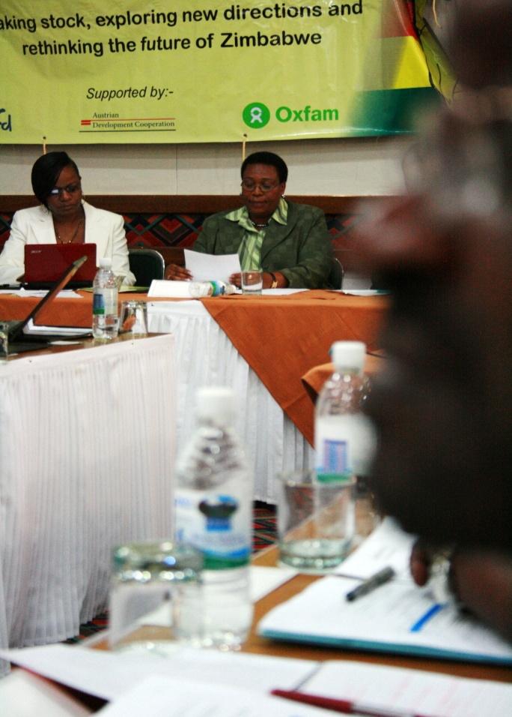
The Minister of Labour and Social Welfare, Hon. Ms P. Mpariwa (MP) speaking.
This quickly became the backdrop to the dialogue by leading members of a broad range of national and regional NGOs, some members of parliament, representatives from the private sector, diplomats and others met at the two day ‘National High Level Dialogue on moving Zimbabwe forward’ meeting in Harare on the 26th and 27th of October. The meeting was chaired by National Director of ActionAid Zimbabwe, Dr. Tsitsi Choruma.
Elections take centre stage
Two years into the Government of National Unity (GNU), it is time to reflect on the context and chart the way forward for Zimbabwe. Special emphasis was on the implementation of the GPA, the finalisation of the constitution making process and on upcoming elections.
However, most of the discussion hovered around the possibility of upcoming elections, a constant reminder that time is scarce for consensus building on positions and priorities and for mass mobilisation and civic education as the best way for civil society to make progress.
“Civil society was divided at the formation of the GNU with some supportive and others sceptical and further divisions have occurred over the constitution making model. The announcement of elections therefore threatened to undermine even more the unity of civil society. So this gathering intended to bring together our common concerns notwithstanding our diversities, in order to map out a common strategy,” says Tinoziva Bere, chairperson of the Zimbabwe Election Support Network, ZESN.
Clear minimum conditions
“We cannot leave the future of Zimbabwe to politicians. We are the people, the mothers, the fathers and the children of this country and we have a right to be heard. At this meeting, we have made tremendous progress in facilitating this,” adds Bob Muchabaiwa, Advocacy Manager of SADC-CNGO.
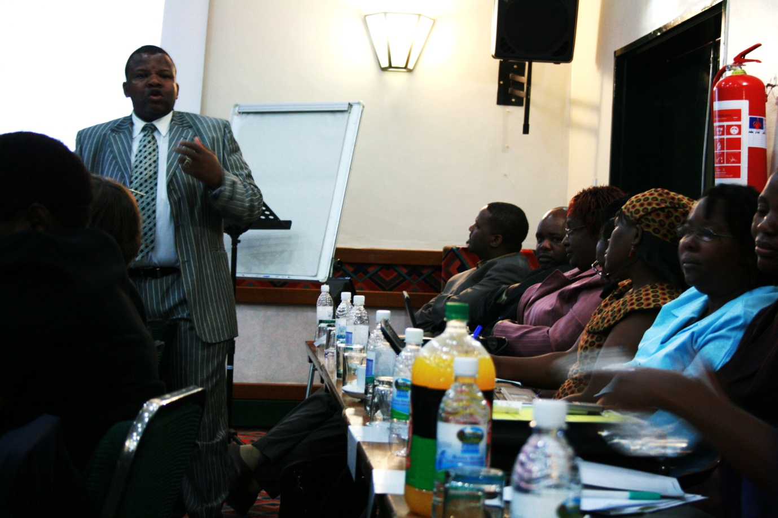
Debate: a large range of presenters provided insight and perspective to the approx. 75 people at the meeting.
After two days of in-depth debating of the situation in Zimbabwe, the possible scenarios in an election and the role of civil society organisations in this regard, a common stand point was adopted that if any elections are to happen, agreement has to be reached on some clear minimum conditions for a free and fair election in line with the SADC principles and guidelines on elections.
“As the one who was facilitating and chairing the dialogue between CSOs and other stakeholders on the future of Zimbabwe, I am happy with the outcomes as they enable CSOs to somewhat come up with unifying positions on how to tackle the challenges currently facing Zimbabwe. Most importantly CSOs were able to on the minimum demands they will be making on the GNU to guarantee free and fair elections if these are to take place.
ActionAid Zimbabwe feels honoured to have been asked by SADC-CNGO to facilitate and chair this meeting. This provided an opportunity to participate on national issues but also to assert ourselves and start to effectively engage with the Zimbabwe crisis beyond the and regional levels,” says ActionAid Zimbabwe national director, Dr. Tsitsi Choruma.

The minimum conditions:
Our common vision is a democratic and peaceful Zimbabwe.
As civil society in Zimbabwe, we are concerned that the current environment is not conducive for free and fair elections and we will therefore focus our energies and resources to ensuer that there are adequate conditions for a fair and free election.
- End to violence (Peace Building, National Healing)
- Institutional Reform (Police, Army)
- Participation of Women
- Legal Framework (Constitution, Electoral Laws and other repressive laws)
- De-securitization of elections
- Equal access to the media, particularly state media
- Independence, full mandate, professionalism and resourcing of ZEC
- Freedom of assembly and for political parties to campaign freely
- Voters Roll (Audit, transparency and ZEC control)
- Role of stakeholders in civic education, election observation e.t.c.
- Disenfranchised voters
- Postal voting
Recommendations to SADC:
Comprehensive plan to ensure that elections in Zimbabwe are peaceful, free and fair.
Ensure parties to the GPA make the requisite electoral reforms.
Comprehensive observations and monitoring of the Zimbabwe elections (pre, during and post)
Presence before, during and after counting and announcement of results.
Ensure smooth installation of winner.

-ENDS -

